Alpha 99 Input RF-Detect Diode Replacement

- Unplug amp, remove cover and transformer.

- Loosen tube clamps, lift up chimneys and clamps from tubes, remove tubes.

- Remove screws from 2 nylon clamps holding coax to the tube deck. Remove screws from both ends of silver plated tank coil, the screws secure the coil to 2 Delrin posts mounted on the tubedeck.

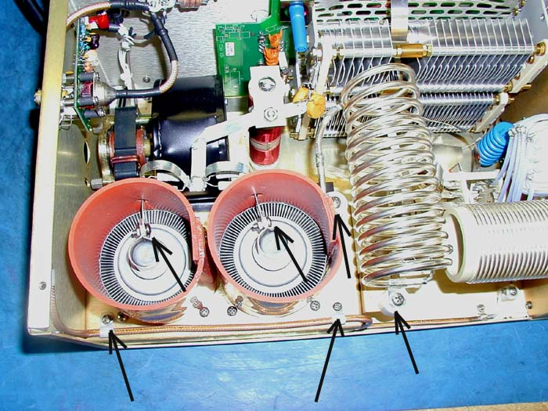

- Remove 3 screws from rear of chassis that secure tubedeck. Two are on either side of, and 1 is above, the RF INPUT SO-239 connector.

- Stand amp on right-hand side and remove 7 screws that secure the tubedeck cover to chassis, remove cover.

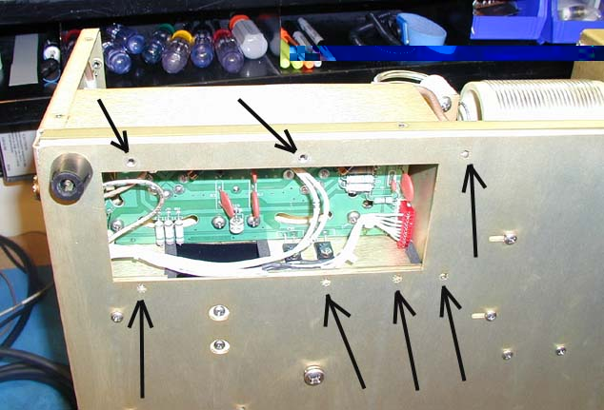

- Remove 4 connectors from tubedeck board. Two RCA plugs with small coax, one 2-pin orange filament voltage connector, and one red 10-pin MTA connector. The red connector will probably need to be gently pried off the board with a small screwdriver or dental pick.
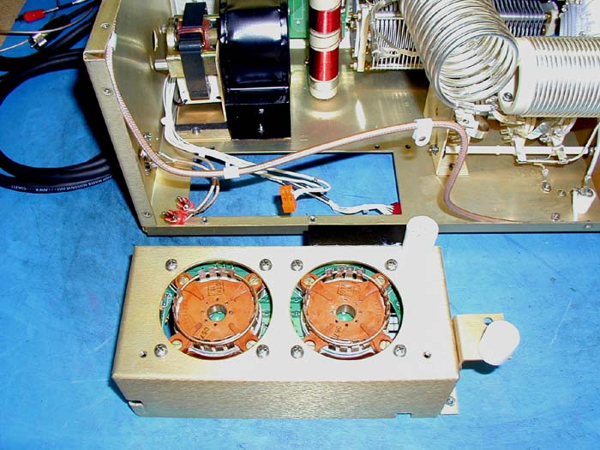

- Lift tubedeck from amp. Replace diodes D3 and D4 and capacitor C17 by unsoldering them from the edge of the board, it is not necessary to remove circuit board from the tubedeck sheetmetal. The ground connection of D3 may be difficult to unsolder due to heatsinking of the ground plane of the circuit board. Be careful not to use too much heat. Replace the new diodes on the bottom of the board.

Install the new C17 value (10 pf) on the same side of the board as before, it cannot be mounted on the bottom because it will interfere with the RCA connectors.

Install the included 15k resistor at location R33 on the Control Board, behind the front panel. When installing front panel on amp, set both variable capacitors with plates fully meshed (max C), TUNE knob = 100, LOAD knob = zero.

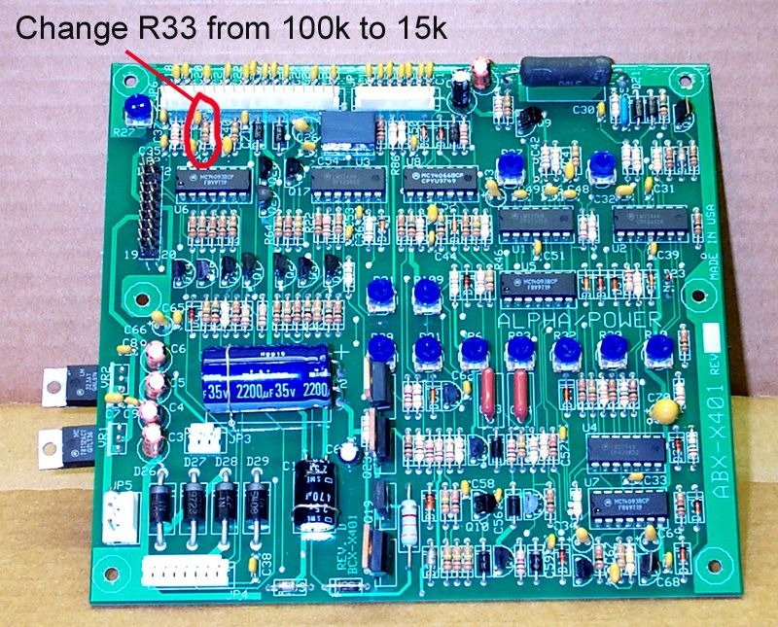
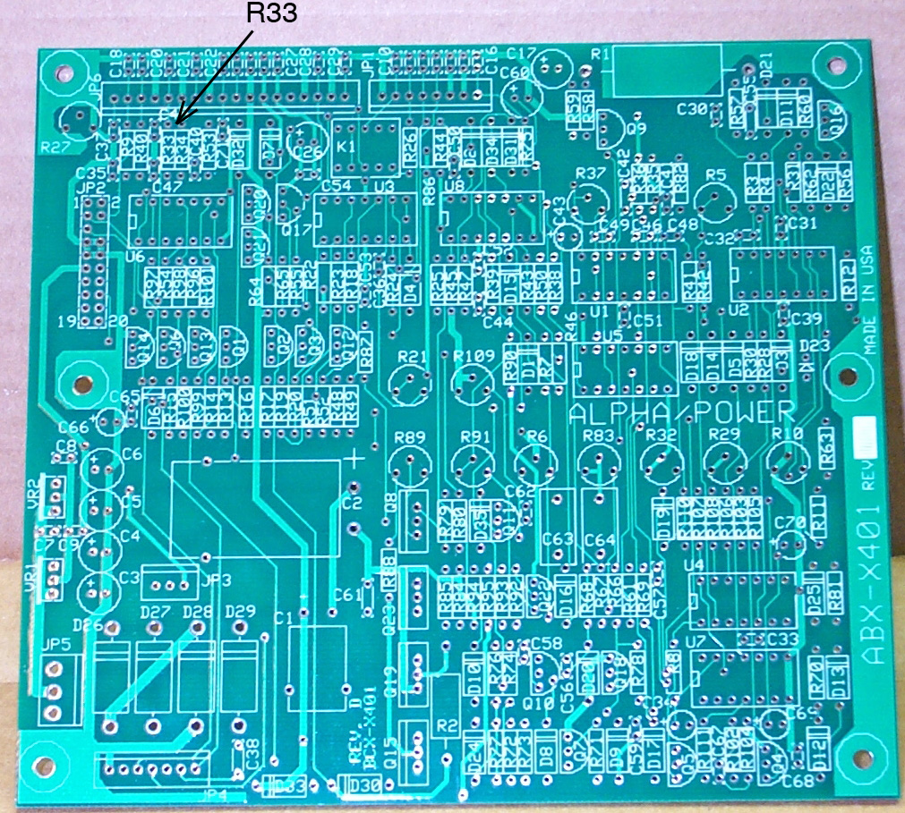

When replacing connectors on the Control Board, be very careful to install JP1(red 8-pin connector) correctly, it is easy to put it on with one pin offset!

- Reassemble tubedeck in reverse order.

- When replacing the tubes in the sockets, do not let any of the socket fingers fold under the tube body.

